**Insert School Logo**

**Semester Two**

**Examination 2020**

**Question/Answer booklet**

**MATHEMATICS**

**METHODS UNITS 3 & 4**

**Section One:**

**Calculator–free**

|  |
| --- |
| Student Name: _____________________________________ |
| Teacher’s Name: _____________________________________ |
|  |

**Time allowed for this section**

Reading time before commencing work: five minutes

Working time for paper: fifty minutes

**Material required/recommended for this section**

**To be provided by the supervisor**

This Question/Answer booklet

Formula Sheet

**To be provided by the candidate**

Standard items: pens (blue/black preferred), pencils (including coloured), sharpener, correction tape/fluid, erasers, ruler, highlighters

Special Items: nil

**Important note to candidates**

No other items may be taken into the examination room. It is **your** responsibility to ensure that you do not have any unauthorised notes or other items of a non–personal nature in the examination room. If you have any unauthorised material with you, hand it to the supervisor **before** reading any further.

**Structure of this paper**

|  |  |  |  |  |  |
| --- | --- | --- | --- | --- | --- |
|  | Number of questions available | Number of questions to be attempted | Working time (minutes) | Marks available | Percentage of exam |
| **Section One**  **Calculator—free** | **7** | **7** | **50** | **50** | **35** |
| Section Two  Calculator—assumed | 15 | 15 | 100 | 100 | 65 |
|  | | | | Total marks | 100 |

**Instructions to candidates**

1. The rules for the conduct of Western Australian external examinations are detailed in the

*Year 12 Information Handbook 2020.* Sitting this examination implies that you agree to abide by these rules.

1. Answer the questions according to the following instructions.

**Show all your working clearly.** Your working should be in sufficient detail to allow your

answers to be checked readily and for marks to be awarded for reasoning. Incorrect answers given without supporting reasoning cannot be allocated any marks. For any question or part question worth more than two marks, valid working or justification is required to receive full marks. If you repeat an answer to any question, ensure that you cancel the answer you do not wish to have marked.

It is recommended that you **do not use pencil**, except in diagrams.

1. You must be careful to confine your responses to the specific questions asked and to follow any instructions that are specific to a particular question.
2. Spare pages are included at the end of this booklet. They can be used for planning your responses and/or as additional space if required to continue an answer.

* Planning: If you use the spare pages for planning, indicate this clearly at the top of the page.
* Continuing an answer: If you need to use the space to continue an answer, indicate in the original answer space where the answer is continued, i.e. give the page number. Fill in the number of the question that you are continuing to answer at the top of the page.

1. The Formula Sheet is **not** handed in with your Question/Answer Booklet.

# Section One: Calculator–free 35% (50 marks)

This section has **seven (7)** questions. Attempt **all** questions. Write your answers in the spaces provided.

Spare pages are included at the end of this booklet. They can be used for planning your responses and/or as additional space if required to continue an answer.

* Planning: If you use the spare pages for planning, indicate this clearly at the top of the page.
* Continuing an answer: If you need to use the space to continue an answer, indicate in the original answer space where the answer is continued, i.e. give the page number. Fill in the number of the question(s) that you are continuing to answer at the top of the page.

Working time: 50 minutes

**Question 1 (7 marks)**

A fledgling business recorded its profits, A, for ten consecutive weeks.

Amounts are rounded appropriately, and given in thousands of dollars.

A = {−1, 0, 1, −1, 0, 2, 1, 1, 0, 1}

(a) Complete the probability distribution for *A*. (2 marks)

|  |  |  |  |  |
| --- | --- | --- | --- | --- |
| *a* | −1 | 0 | 1 | 2 |
| P(*A* = *a*) |  |  |  |  |

(b) Show that the mean amount for the ten week period is $400. (2 marks)

The variance of *A* is partially calculated below.

(c) Complete the calculation. (3 marks)

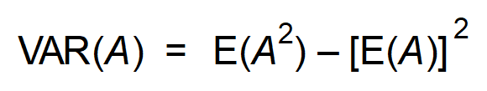

**Question 2 (7 marks)**

A school has five administrative staff; one male and four females.

One of the five is selected at random.

The random variable *M* represents the number of males selected.

The probability distribution of *M* is given, in part, below.

|  |  |  |
| --- | --- | --- |
| *m* | 0 | 1 |
| P(*M* = *m*) |  |  |

(a) Complete the table. (2 marks)

(b) Explain why *M* is said to be a Bernoulli variable. (1 mark)

(c) Determine the mean and standard deviation of *M*. (2 marks)

The selection process is repeated eight times. Each selection is independent of the other selections, and is completely random.

*X* is the total number of selections resulting in a male staff member. *X* is binomial.

(d) State the parameters of *X*. (1 mark)

(e) State an expression representing the probability of selecting the male staff member

on three occasions. Do not attempt to evaluate that expression. (1 mark)

**Question 3 (11 marks)**

(a) Differentiate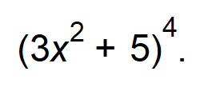Do not simplify. (2 marks)

(b) A function, g, is defined as 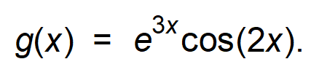

Determine the exact rate of change of g with respect to x at the instant that x = π. (3 marks)

(c) Determine in simplest form:

(i) 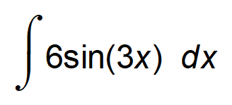 (2 marks)

(ii) 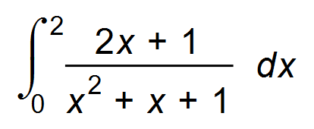 (2 marks)

(d) Given that 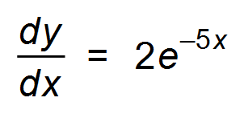, determine the expression for y if y(0) = −3. (2 marks)

**Question 4 (6 marks)**

You should be familiar with the 68 − 95 − 99.7 rule for normally distributed data values.

Use those values to answer the following questions about normally distributed variable *X*,

where *X* is the life span of mobile phone cameras.

*X* has a mean of 7 years and a standard deviation of 1.5 years.

(a) Determine, with working, the expected range of such life spans. (2 marks)

(b) Approximately what percentage of cameras have a life span less than 5.5 years? (2 marks)

(c) The smallest 2.5% of life spans qualify for replacement with a new phone for the owner.

What is the smallest life span that qualifies for a new phone? (2 marks)

**Question 5 (3 marks)**

A 90% confidence interval has a width of 5, based on a sample size equal to *n*.

What sample size is required for a 90% confidence interval to have a width of 10?

(3 marks)

**Question 6 (10 marks)**

(a) (i) Determine an expression for 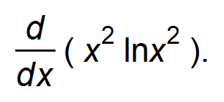 (2 marks)

(ii) Use your answer to (i) to show that 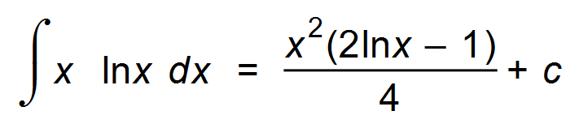 (4 marks)

(b) The graph of y = x lnx is shown below.

Determine the shaded area. (4 marks)

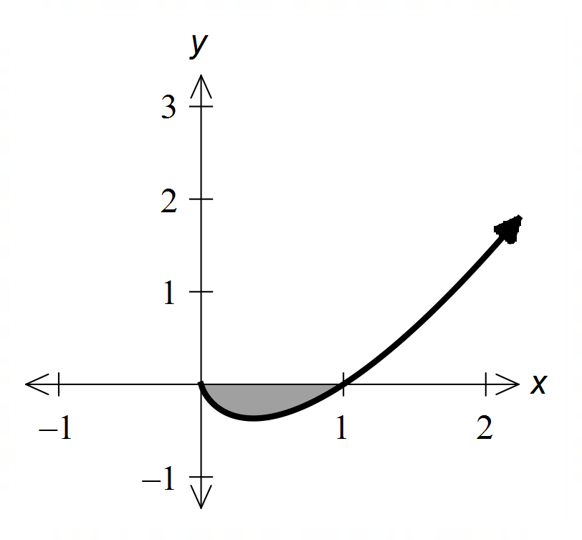

**Question 7 (6 marks)**

The graph of 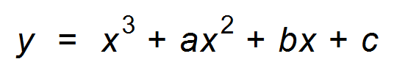 is shown below.

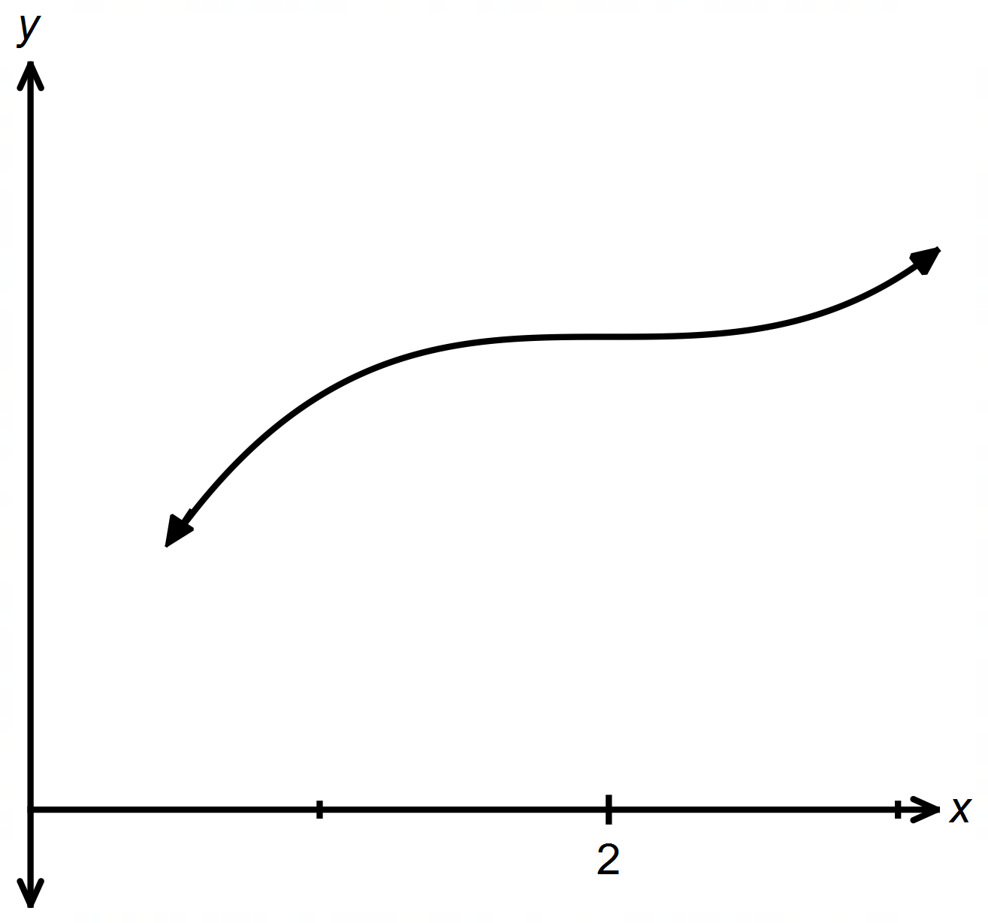

A horizontal point of inflection occurs at (2, 8).

Determine the values of a, b and c. (6 marks)

**End of Questions**

**Additional working space**

Question number(s): ……………………

**Additional working space**

Question number(s): ……………………